New College Connection

|  |  |
| --- | --- |
| Passion for Auto Racing | 2 |
| Ryan Davis | 2 |
| Alumni notes | 2 |
| Hiking the AT | 3 |
| New Minor | 3 |
| Where are they now? | 3 |
| Senior Accomplishments | 4 |

Dr. Ellen Spears book, *Baptized in PCBs: Race, Pollution, and Justice in an All-American Town*, recounts the legal fight that began in Anniston in the 1990s against the agrochemical company Monsanto over the dumping of toxic chemicals in the city’s historical African American and white working-class west side, as well as the campaign to safely eliminate chemical weaponry secretively stockpiled near Anniston during the Cold War. *Baptized in PCBs* is a narrative history that follows Anniston’s trajectory from its late 19th century designation as the “Model City of the New South” to its 2002 label as “Toxic Town USA.”

### http://www.as.ua.edu/nc/

## Dr. Ellen Spears Publishes New Book Set in Anniston, AL

Meet Dr. Spears

* B.A. – College of William and Mary (Psychology)
* MA and PhD – Emory University’s Graduate Institute of the Liberal Arts (American Studies)
* Early career – worked for 20 years in social justice non-profit organizations
* Hobbies – weaving and photography

Inside this issue:

# MacArthur “Genius Grant” Recipient Anthony Braxton Coming to UA

Thanks to the efforts of Dr. Andrew Dewar, MacArthur “Genius Grant” recipient, composer, and saxophonist Anthony Braxton will spend a week at UA in spring 2015. Dewar was awarded a NEA “Art Works” grant that will partially fund Braxton’s weeklong-residency. Saxophonist/composer Anthony Braxton is a major figure of contemporary music, an NEA Jazz Master, and Professor Emeritus at Wesleyan University. His work spans a kaleidoscopic range of music, from jazz quartets to string quartets, operas, music for orchestra, electronic music, and even a piece for 100 tubas. In addition to several performances with his professional ensemble (which includes Dr. Dewar), Braxton, during his residency at UA, will be working with Professor Chris Kozak’s jazz orchestra and Dr. Tim Feeney’s percussion ensemble in the School of Music. He will also perform with dance students of Professor Sarah Barry from the Department of Theatre and Dance. New College students will have the opportunity to interact with Braxton in a variety of settings. “It should be a pretty remarkable week that will galvanize and inspire our community,” said Dr. Dewar.

Stay tuned for more information about Braxton’s visit.

May 2014

Volume 2, Issue 1

In the daytime, Ryan Davis is a business analyst at Cerner Corporation in Kansas City, Missouri. At night, Davis moonlights as a rapper, producer, and trombonist. He has collaborated with underground hip hop artists Richie Branson and Mega Ran and with renowned voice actor Steve Blum. He has produced music for Toonami Asia, opened for hip-hop star B.O.B. and performed live at the Cannes Film Festival. In delivering the Honors Day address, Davis told New College scholarship recipients that it is his interdisciplinary degree that has allowed him to marry his diverse passions. “New College provided an environment in which I could satiate my hunger and embrace whatever risks came with it,” Davis told the packed audience. Davis said that New College created for him a culture in which he did not fear failure, but rather embraced it. He emphasized the importance of taking risks with a closing quote from University of Kentucky basketball coach John Calipari whose team narrowly defeated Michigan in the Elite 8 with a last minute 3-point shot: “You can’t be afraid to miss the shot. You just have to take it.”

## Alumni notes

Dr. Dan McNeil, a psychology professor at West Virginia University and a 1977 graduate of New College, was recently named a Claude Worthington Benedum Distinguished Scholar Award winner. His work on pain, fear, and dental health is recognized worldwide. In speaking of the importance of Dr. McNeil’s research in behavioral dentistry, Dr. Kevin Larkin, chair of WVU’s psychology department, stated “understanding the intricate connections between the experience of fear and pain is essential in promoting oral health. [McNeil’s research] serves as an excellent example of cross-discipline translational science.” Dr. McNeil was also a Fulbright Senior Scholar in 2010.

New College

*201 Lloyd Hall*

*Tuscaloosa, AL 35487-0229*

*205-3484600*

Want to know about auto racing from a woman’s perspective? Check out New College graduating senior Claire Cochran’s blog DoubleXSpeed (<http://doublexspeed.wordpress.com>). For the month of April leading up to Talladega, Claire was a blog contributor on Talladega’s homepage. Claire is not the stereotypical NAS CAR enthusiast. She and her father began watching auto racing when she was in 7th grade simply as a way for father and daughter to bond. As her love for the sport grew, she and her father attended at least one race a year. Claire has grown accustomed to surprised looks when she tells people she plans to work for an Indy Car team someday. Her usual retort is “Yes, I love cars. I’ve had a passion for cars ever since I was born.” As part of her depth study, Claire completed a three-semester co-op with BMW. This summer she is studying abroad and plans to attend the Formula One race in Austria. When she returns from Europe, she hopes to secure a job at the Circuit of Americas in Austin, hopefully moving up to be head of event operations at the racetrack.

## Ryan “Kadesh Flow” Davis Delivers Honors Address

## NC Senior Claire Cochran’s Passion for Auto Racing

## New College Now Houses the Natural Resource Management Minor

New College is the new home of the Natural Resource Management Minor. Dr. Carl Williams coordinates the program. The minor has an interdisciplinary, practice-driven focus that prepares students for professional opportunities in environmental monitoring, such as endangered species and wetland delineation, restoration of disturbed land, and management of forested lands and wildlife areas. Dr. Williams and 12 students in the NRM minor volunteered in March at the 2014 Alabama’s Governor’s One Shot Turkey Hunt. The goal of the Governor’s Hunt is to showcase Alabama as a preferred destination for business, industry, and nature-based recreation. Another primary focus of this event is to fund scholarships for the School of Forestry and Wildlife Sciences at Auburn University and the College of Arts & Sciences at The University of Alabama.

The minor is open to students in the College of Arts and Sciences and in the Culverhouse College of Commerce. For more information, contact [carl.williams@ua.edu](mailto:carl.williams@ua.edu)

**Derrick Taff** (NC 2003) is an Assistant Research Professor in the Recreation, Park, and Tourism Management Department at Penn State University. He enjoys cycling and hiking with his wife Patricia Spears-Taff (also a NC alum – 2006) and their dog Yoshi.

**Lisa Darnley Cooper** (NC 95) is a lawyer for Hand Arendall LLC’s Mobile office and recently received the William Kaufman award by the Community Foundation of South Alabama.

**Mary Margaret Randall** (NC 2010) serves as an AmeriCorps VISTA Volunteer in Nashville, TN with Girls on the Run, an international nonprofit that serves as a bridge between the next generation of young girls and a positive and healthy future.

## Where are they now?

While other seniors spent their final semester sitting in the classroom, writing papers, preparing for the GRE, or taking exams, New College student William Wells was hiking the Appalachian Trail (AT), which runs from Georgia to Maine.

Wells, whose depth study is wildlife and land management, began planning the trip as part of his final project in NEW 212 (Creativity). His NEW 212 instructor, Professor John Miller, recalls that Wells had a hard time coming up with a final project for the class. “I suggested that he combine his enthusiasm for outdoor leadership with creativity and create a trip plan for a hypothetical trip to important natural attractions around the world. He did a great job, so when he came to me to discuss a real-world version for hiking the AT, I knew he could bring what he had learned while pursuing his depth study to the project,” Miller said.

New College professor Dr. Michael Steinberg, an avid outdoorsman himself, was also instrumental in helping Wells plan and execute this trip.

Wells plans to reach the end of the trail in July.

phone

## New College Senior Hikes the Appalachian Trail

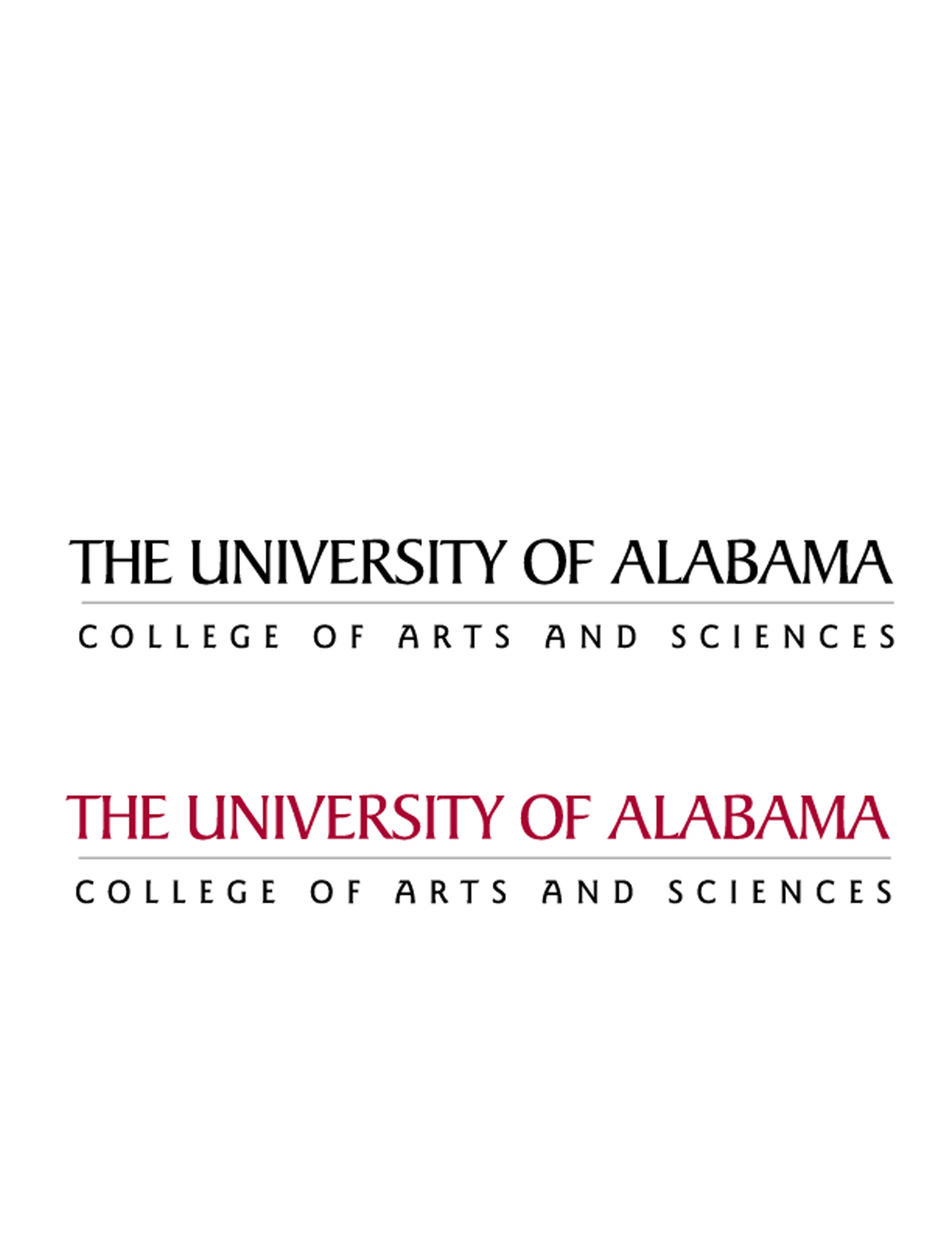

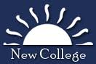

**Congratulations to the following New College seniors:**

**Jason Arterburn** – 2014 Truman Scholar

**Mary Sellers Shaw** – Morris Lehman Mayer Award recipient

**Sarah DeMeo** – Woodrow Alvin Davis Family Student Athlete Award recipient

**Alex Vawter** – Outstanding Student in Latin and Greek; Bernard C & Alma B. Webber Scholarship recipient

**Olivia Bensinger** - Byron Franklin and Ophelia Burks Watson Scholarship recipient

**Jennifer Davidson** - Byron Franklin and Ophelia Burks Watson Scholarship recipient

**Lindsay Lord** – Samuel Thomas Barnes IV Memorial Scholarship recipient

**James Goyer** - Samuel Thomas Barnes IV Memorial Scholarship recipient

**Morgan Embry** – Samuel J. Senter Scholarship recipient

**Tyler Wester, Rebecca Foster, John Thomason, Michael Battito, Amber Brown, Parker Hall, Sara Johnson, Mary Sellers Shaw** – Levitetz Award recipients

**Lizzie Ernstberger** – Raised $10,000 for the Capstone Rural Health Center Community Garden

**Asher Elbein** – Partnered with the Alabama Museum of Natural History to bring his gallery of paleontology art to Smith Hall

Let us know what you are doing now:

nadams@as.ua.edu

## Senior Accomplishments